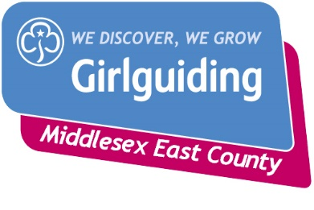
InforME ~ March 2023
Welcome to your monthly update for March 2023 from Girlguiding Middlesex East!
This mailing goes to all County 18+ who have signed up to receive marketing communications.

County Day 2023

Sadly there has been very little interest in having a county day so the planned event will be cancelled.

County Commissioner

Reminder applications/nominations are now open for the next County Commissioner closing date 12th March email amandat@girlguidinglaser.org.uk

County Awards Chair

We are now looking for a new County Awards Chair as Alison has come to the end of her term and is stepping down due to her other roles.

AED – Automated External Defibrillator

If you have an AED at your venue meeting place please ensure it is included on your Unit meeting Risk Assessment

First Response course

18th March in N14

22nd April in EN5

Book via training@ggme.co.uk

Tourniquets

The use of tourniquets is now being taught on First Response trainings.

A Safe Space 3

From Guiding website – Reminder re unit requirements

There must be a level 3 A Safe Space holder at every unit meeting. In order to give units maximum flexibility we recommend that all leaders, assistant leaders and leaders in training hold level 3, but this is not a mandatory requirement.
However we recommend that all leaders complete this level 3, as well as mentors, advisers, coordinators (except GO coordinators), licence holders on residentials, trainers, tutors, anyone leading a team of adults, and those doing level 4.
Don't forget you will also need to complete Levels 1 and 2
All volunteers require ASS1 and the majority of roles also require ASS2 regardless of what other volunteers in the unit hold.
All ASS trainings are accessible via the Learning platform if you are having issues logging in please contact Membershipsystems@girlguiding.org.uk

NEW: A Safe Space Level 3 and Level 4 courses can now be booked in any Country/Region

The Learning Platform has been updated so volunteers can book directly on to a Level 3 and Level 4 A Safe Space course being run by any C/R – this is ahead of schedule! The list can be accessed by selecting ‘A Safe Space’ on the home page – rather than by searching for Level 3 or Level 4. The attached document shows the steps to take for Level 4 - just select Level 3 instead.

Northern Heights

Crystal is still doing Bookings and can be contacted on NHBookings@ggme.co.uk

In the meantime, any queries can be sent to Alison Nugent – alisonmnugent@gmail.com

Jack Petchey Evening Returns
The Jack Petchey presentation evening returns next year for the 2022 award winners.
It will be held at the Millfield Theatre, Edmonton on Wednesday 15th March 2023.
Please advise your award winners now of this date.
Details of the evening will be issued in February next year.
This will also include presentations to Leader Award winners from 2021 and 2022.
If you would like to volunteer entertainment for the evening, please email details
to Iris at i.prince579@btinternet.com.

